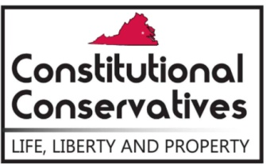
2019 County Candidate Survey
“Our mission is to promote and defend the great American principles of individual liberty, constitutional government, sound money and free markets by means of political activity and grassroots mobilization.”

Dear Candidate,

Virginia Constitutional Conservatives is a growing group of citizens who believe passionately in preserving individual freedom and constitutional government.
Your position on issues relating to the preservation of our Constitution, limited government, and individual liberty is of very strong interest to our members in your district. Would you please take a moment to complete and return the enclosed legislative survey?
The survey results may be shared with our members.
In preparing for both the 2019 election cycle, we are trying to ascertain the policy positions of Candidates for the Board of Supervisors. To expedite your reply you can scan both pages of the survey and email it to info@virginiaconservatives.net or you may mail it to us at 11293 Allium Lane, Lovettsville, VA 20180.
Responses are due back on April 1, 2019.

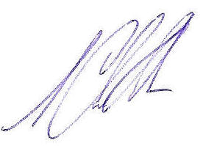
In Liberty,

S. Chris Anders
Director
Virginia Constitutional Conservatives

P.S. Please feel free to make comments in the space provided on page three of the survey. Though we may not publish this information to our members, it is often helpful in understanding your position. Our members may wish to call you for further information, so please include your phone number in the returned survey.

